**MINI-PROJECT REPORT ON**

**“COVID VACCINE STATE ANALYTICS’’**

**Submitted By**

**Mr. Thorve Avishkar Shrikrushna**

**Roll No: 63**

**Exam No: T400840394**

**Class: TE AIDS**

**UNDER THE GUIDANCE OF**

**Prof. Rokade N. G.**

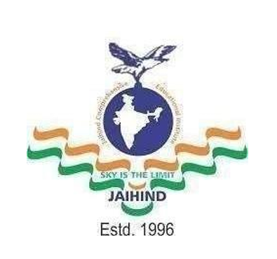

**Department of Artificial Intelligence and Data Science Engineering**

**Jaihind College of Engineering, Kuran**

**A/p-Kuran, Tal-Junnar, Dist-Pune-410511, State Maharashtra, India**

**2024-2025**

**Department of Artificial Intelligence and Data Science Engineering**

**Jaihind College of Engineering, Kuran**

**A/p-Kuran, Tal-Junnar, Dist-Pune-410511, State Maharashtra, India**

**2024-2025**

**CERTIFICATE**

This is to certify that the Internship Report Entitled

**“COVID VACCINE STATE ANALYTICS’’**

SUBMITTED BY

**Thorve Avishkar Shrikrushna**

Is a Bonafide work carried out by student under the supervision of **Prof. Rokade N. G.** and it is submitted towards the partial fulfilment of the requirement of third year of Engineering in Artificial intelligence and data science under the Savitribai Phule Pune University during the academic year 2024-2025.

**Prof. Rokade N. G. Prof. S. K. Said**

(Subject Teacher)  **(**HOD AI&DS)

JCOE, Kuran. JCOE, Kuran.

**ACKNOWLEDGEMENTS**

With deep sense of gratitude we would like to thank all the people who have lit our path with their kind guidance. We are very grateful to these intellectuals who did their best to help during our project work. It is our proud privilege to express a deep sense of gratitude to Principal of Jaihind College Of Engineering, Kuran **Dr. D. J. Garkal** for his comments and kind permission to complete this project. We remain indebted to H.O.D.Artificial Intelligence And Data Science Engineering Department **Prof. S. K. Said,** for his timely suggestion and valuable guidance. The special gratitude goes to **Prof. Rokade N. G.** excellent and precious guidance in completion of this work .We thanks to all the colleagues for their appreciable help for our working project. With various industry owners or lab technicians to help, it has been our endeavor throughout our work to cover the entire project work. We are also thankful to our parents who provided their wishful support for our project completion successfully .And lastly we thank our all friends and the people who are directly or indirectly related to our project work.

Yours faithfully,

**Mr. Thorve Avishkar Shrikrushna.**